### Material UI

#### Objectives and Outcomes

In this exercise we learn to use the React Materialize components to configure and set up your template in a React application for the routes: path =’/contact’, path=’/news’, path=’detail’. At the end of this exercise, you will be able to:

* Install and configure your application to use React Material components such as: Modal, Form elements, Collapsible, Tab, … .
* Rebuild your React application using react Material for your template at contact, detail, news components.

#### Style your contact component

* Design by yourself in file Contact.js using React Materialize components for form elements, the screen display as a reference:

* Preventing the submit action of form:

const handleSubmit =(e)=> {

e.preventDefault()

}

#### Style your About component

* Design by yourself in file About.js using Collapsible of React Materialize components, The screen display as a reference:

#### Style your Detail component

* Design by yourself in file Detail.js using Modal of React Materialize components for show the video of Player when click to the video icon, the screen display as a reference:

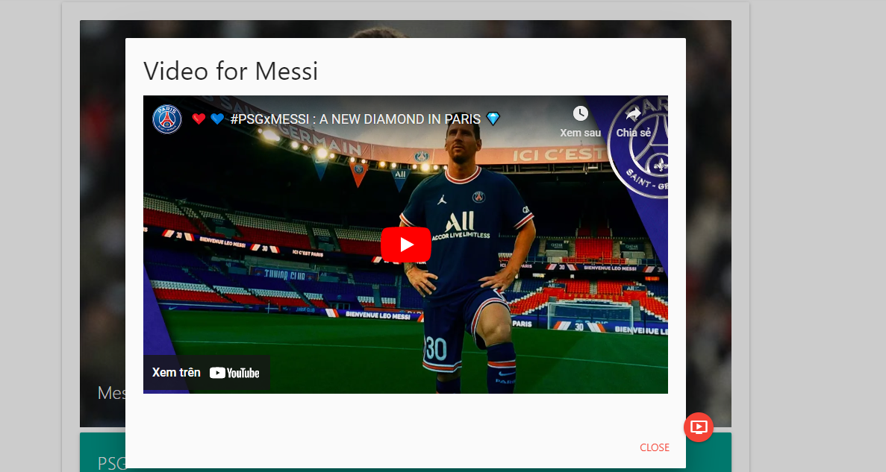

* Update your ListOfPlayers.js file to adding the clip URL (Youtube URL) as follow:

{…, clip:'https://www.youtube.com/embed/9_O6TSyYAlE', …}

* Some steps for declaring and using the Modal component:
* Update The Detail.js file:

Using useState hook:

import { useState } from 'react';

…

export default function DetailPlayer() {

const [isOpen, setIsOpen] = useState(false);

* Set the State *SetIsOpen(true)* when users click to the video icon:

<a onClick={() => setIsOpen(true)} className="btn-floating halfway-fab waves-effect waves-light red">

<Icon>ondemand_video</Icon>

</a>

* Create The ModalCase.js file for containing the Modal:

* CSS for className=’modal-show’ at App.CSS:

.modal-show {

background-color: rgba(0, 0, 0, 0.2);

width: 100vw;

height: 100vmax;

z-index: 99;

top: 50%;

left: 50%;

transform: translate(-50%, -50%);

position: absolute;

}

* Update The Detail.js file for importing the ModalCase component, conditional renderings and passing  *props of player* to Modal:

…

import ModalCase from './ModalCase';

…

{isOpen && <ModalCase setIsOpen={setIsOpen} player={player} />}

* Update The ModalCase.js file for using the state *SetIsOpen* and the *clip prop* which is passed from the Detail component:

#### Create your News component

Using the Tab React Material component for building your News component at route ‘/news’

(Students build by yourself)

#### Conclusions

In this exercise you learn about installing, configuring and using the React Materialize components (Modal, Collapsible, Tab, Form elements,…) for your React app.